

ID.A.T.S..UNI
�
1981
DATSUN 210
SERVICE MANUAL

�
INISSANI
�

DATSUN
210
Model 8310 Series

FOREWORD
This service manual has been prepared pri• marily for the purpose of assisting service personnel in providing effective service and maintenance of the 1981 DATSUN 210.
This manual includes procedures for main· tenance, adjustments, removal and installa· tion, disassembly and assembly of corn• ponents, and trouble•shooting.
All information, illustrations and specifica· tions contained in this manual are based on the latest product information available at the time of publication. If your DATSUN model differs from the specifications con• tained in this manual, consult your NISSAN/ DATSUN dealer for information.
The right is reserved to make changes in specifications and methods at any time with· out notice.
QUICK REFERENCE INDEX
GENERAL INFORMATION•··········..··•···•···•······•····• GI

MAINTENANCE ·•········•••·••·•••··••··••••····••··••••• MA

ENGINE MECHANICAL.....·..···•··..··········...·. EM

ENGINE LUBRICATION & COOLING SYSTEMS LC
!

ENGINE FUEL ··················...· Ef

EMISSION CONTROL SYSTEM [C

ENGINE REMOVAL & INSTALLATION ··•················· [ff

ENGINE CONTROL,FUEL & EXHAUST SYSTEMs fE

CLUTCH ······..··..··············..··..··············..······ CL

MANUAL TRANSMISSION MT

AUTOMATIC TRANSMISSION AT

PROPELLER SHAFT& DIFFERENTIAL CARRIER po

FRONT AXLE & FRONT SUSPENSION•• FA

REAR AXLE & REAR SUSPENSION•. RA

BRAKE SYSTEM BR

STEERING SYSTEM······..••. ST

NISSAN MOTOR CO., LTD.

© 1980 NISSAN MOTOR CO., LTD.
Printed in Japan
Not to be reproduced in whole or in part without the prior written permission of Nissan Motor Com-pany Ltd., Tokyo, Japan.
BODY BF

HEATER & AIR CONDITIONER·••• •••··••··. HA

ELECTRICAL SYSTEM H

&;_H_o_w_1_o_us_E_T_H_1s_M_A_N_u_A_L I
- This Service Manual is designed as a guide for servicing cars.
- This manual is divided into 19 sections. The first half of the manual presents sections which concern the engine, and the second half presents sections which deal with the chassis and body.
- A QUICK REFERENCE INDEX is provided on the first page. Refer to this index along with the index of the particular section you wish to consult.
- The first page of each section lists the contents and gives the page numbers for the respective topics.
- SERVICE DATA AND SPECIFICATIONS are contained in each section.

- TROUBLE DIAGNOSES AND CORRECTIONS are also included in each section. This feature of the manual lists the likely causes of trouble and recommends the appropriate corrective actions to be taken.
- A list of SPECIAL SERVICE TOOLS is included in each section. The special service tools are designed to assist you in performing repair safely, accurately and quickly. For information concerning how to obtain special service tools, write to the following address:

Kent-Moore Corporation 29784 Little Mack
Roseville, Michigan 48066
Kent-Moore of Canada, Ltd. 2395 Cawthra
Mississauga, Ontario
Canada LSA 3P2

- The measurements given in this manual are primarily expressed with the SI unit (International System of Unit), and alternately expressed in the metric system and in the yard/pound system.
- The back cover of the manual provides maintenance data for quick reference.
- In the text, the following abbreviations are used:
S.O.S.: | Service Data and Specifications | L.H., R.H.. | Left Hand, Right Hand
(rl: | Tightening Torque | M/T, A/T· | Manual Transmission, Automatic Transmission

- The captions CAUTION and WARNING warn you of steps that must be followed to prevent personal injury and/or damage to some part of the car.

� IMPORTANT SAFETY NOTICE I
The proper performance of service is essential for both the safety of the mechanic and the efficient functioning of the car.
The service methods in this Service Manual are described in such a manner that the service may be per-
formed safely and f!CCurately.
Special service tools have been designed to permit safe and proper performance of service. Be sure to use them.

Service varies with the procedures used, the skiIIs of the mechanic and the tools and parts available. Accordingly, anyone using service procedures, tools or parts which are not specifically recommended by NISSAN must first completely satisfy himself that neither his safety nor the car's safety will be jeopardized by the service method selected.

MANUAL TRANSMISSION

CONTENTS

REMOVAL AND INSTALLATION ....... MT- 2 REMOVAL ......................... MT- 2
INSTALLATION ..................... MT- 2
5-SPEED TRANSMISSION
(Model: FSSW6OA) MT- 3
DISASSEMBLY ...................... MT- 4 TRANSMISSION CASE DISASSEMBLY . MT- 4 DISASSEMBLY OF GEAR ASSEMBLY .. MT- 5 REAR EXTENSION DISASSEMBLY .....MT- 8 INSPECTION ....................... MT- 8
TRANSMISSION CASE AND
REAR EXTENSION ................ MT- 8
BEARINGS ....................... MT- 8 GEARS AND SHAFTS·.............. MT- 9
BAULK RING .................... MT- 9
SHIFTING INSERT .................MT- 9
OIL SEAL ....................... MT- 9 REAR ENGINE MOUNTING
INSULATOR ...................... MT- 9 ASSEMBLY ............... MT· 9
FRONT COVER ASSEMBLY .......... MT- 9 TRANSMISSION CASE ASSEMBLY .... MT- 9 REAR EXTENSION ASSEMBLY ....... MT-10 ASSEMBLY OF GEAR ASSEMBLY .....MT-10 TRANSMISSION ASSEMBLY ..........MT-14
4-SPEED TRANSMISSION
(Model: F4W6OL) ................. MT-16
DISASSEMBLY . . . . . . . . . . . . . . . . . . . . . MT-17 TRANSMISSION CASE DISASSEMBLY . MT-17 DISASSEMBLY OF GEAR ASSEMBLY . MT-18 ADAPTER PLATE DISASSEMBLY ..... MT-22 REAR EXTENSION DISASSEMBLY .... MT-22 INSPECTION . . . . . . . . . . . . . . . . . . . . . . MT-22
TRANSMISSION CASE AND REAR
EXTENSION . . . . . . . . . . . . . . . . . . . . . MT-22
BEARINGS. . . . . . . . . . . . . . . . . . . . . . MT-22 GEARS AND SHAFTS MT�2
BAULK RING ............ ,.. .... MT-23
SHIFTING INSERT. . . . . . . . . . . . . . . . MT-23
OIL SEAL . . . . . . . . . . . . . . . . . . . . . . MT-23 REAR ENGINE MOUNTING
INSULATOR. . . . . . . . . . . . . . . . . . . . . MT-23
ASSEMBLY MT-23
FRONT COVER ASSEMBLY .......... MT-23 TRANSMISSION CASE ASSEMBLY ..... MT-23 REAR EXTENSION ASSEMBLY ....... MT-23 ADAPTER PLATE ASSEMBLY ........MT-24 ASSEMBLY OF GEAR ASSEMBLY ..... MT-24 TRANSMISSION ASSEMBLY .......... MT-27
4-SPEED TRANSMISSION
(Model: F4W56A) ................... MT-29
DISASSEMBLY ...................... MT-30 TRANSMISSION CASE DISASSEMBLY .. MT-30 DISASSEMBLY OF GEAR ASSEMBLY . MT-31 REAR EXTENSION DISASSEMBLY ..... MT-34
34
IN�:���%�SSION C�SE. AN.O ·R·E-AR •••••MT- - EXTENSION ...................... MT-34
BEARINGS ....................... MT-34 GEARS AND SHAFTS .............. MT-34 SYNCHRO HUB THRUST WASHER .... MT-35 BAULK RING .................... MT-35
SHIFTING INSERT ................. MT-35
OIL SEAL ....................... MT-35 REAR ENGINE MOUNTING
INSULATOR ...................... MT-35
ASSEMBLY ........................ MT-35 FRONT COVER ASSEMBLY .......... MT-35 TRANSMISSION CASE ASSEMBLY .....MT-35 REAR EXTENSION ASSEMBLY .......MT-36 ADAPTER PLATE ASSEMBLY .......MT-36 ASSEMBLY OF GEAR ASSEMBLY .... -MT�6 TRANSMISSION ASSEMBLY .......... MT-39
SERVICE DATA AND
SPECIFICATIONS (S. D.S.) ............ M-4T1
GENERAL SPECIFICATIONS ............ MT-41 INSPECTION AND ADJUSTMENT ........ MT-42 TIGHTENING TORQUE .............. MT-43
TROUBLE DIAGNOSES AND
CORRECTIONS ...................... MT-44
SPECIAL SERVICE TOOLS ........... MT-48

REMOVAL AND INSTALLATION

REMOVAL
To dismount transmission from the car, proceed as folJows:
I. Disconnect battery ground cable.
- Remove console box and detach rubber boots if so equipped.
- Place transmission control lever in neutral position.

  - F4W56A
- Remove E-ring and control lever.
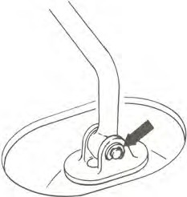
TM013A
  - FS5W60A, F4W60L
- Remove control lever.
Note: Plug up the opening in the rear extension to prevent oil from flow-ing out.
10. Remove clutch operating cylin-der.
I I . Support engine by placing a jack under oil pan with a wooden block used between oil pan and jack.

CAUTION:
Do not place the jack under the oil pan drain plug.

- Support transmission with a transmission jack.
- Loosen rear engine mount secur-ing bolts G) temporarily and remove crossmember mounting bolts @.
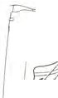
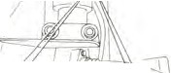
®
r
�l]j,�I I
,,_/-r;,,;-..-,.,.,.�,B
;::,.._
-

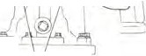
/ �
Ir
.

r
G)
I. Before installing, clean mating surfaces of engine rear plate and trans-mission case.
- Before installing, lightly apply grease to spline parts of clutch disc and main drive gear. And also apply grease to moving surfaces of control lever and striking rod.
- Remove filler plug and fill trans-mission with recommended gear oil to the level of the plug hole.
Oil capacity:
FS5W60A, F4W56A
  - liters
(2-1/2 US pt, 2-1/8 Imp pt)
F4W60L
  - liters
(2-3/4 US pt, 2-1/4 Imp pt)

- Apply sealant to threads of filler plug, and install filler plug to transmis-sion case.
f : Filler plug
25 - 39 N·m
(2.5 - 4.0 kg-m,
18 - 29 ft-lb)

- Tighten bolts securing transmis-sion to engine.

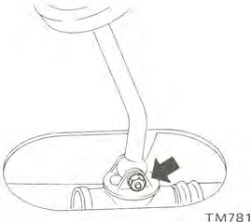
SMT163
CI): 16 -22 N•m
(1.6 • 2.2 kg-m, 12-16ft-lb)

- Jack up the car and support its weight on safety stands. Use a hy-draulic hoist or open pit, if available.
Make sure that safety is insured.
- Disconnect front exhaust tube and remove bolt securing exhaust mounting bracket.
- Disconnect wires from reverse (back-up) lamp, Neutral, Top and
O.D. gear (if so equipped) switches.
- Disconnect speedometer cable.
- Remove prope!Jer shaft.
Refer to Propeller Shaft {Section
PD) for removal.
- Remove starter motor.
IS. Remove bolts securing trans-mission to engine and gusset.
Then, support the engine and trans-mission with jacks, and slide transmis-sion rearward away from engine and remove from the car.

CAUTION:
Take care in dismounting transmission not to strike any adjacent parts and main drive gear.

INSTALLATION
Install the transmission in the re-verse order of removal, paying atten-tion to the following points:

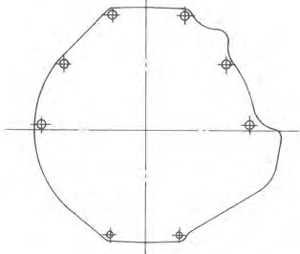

SMT164

- Lubricate oil seal lip and bushing on rear extension with gear oil for initial lubrication.

5-SPEED TRANSMISSION (Model • FS5W60A)

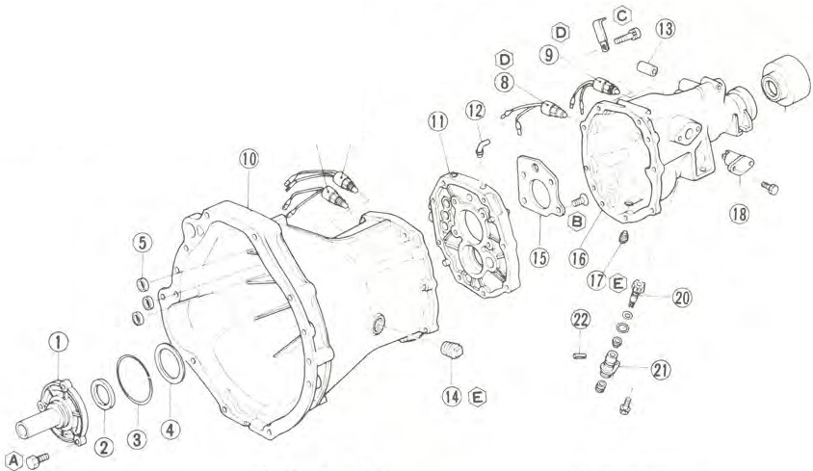
Tightening torque: N·m (kg-m, fr-lb)
@) 10 - 16 ( l.0 - 1.6, 7 - 12)
1'@ 6.9 - 9.8 (0.7 • l.0, 5.1 • 7.2)
© 16-22 (1.6-2.2, 12-16)
- 20 • 34 (2.0 • 3.5, 14 - 25)
I;] 25 - 39 (2.5 -4.0, 18 - 29)

@@
® (J) I
@

  - Drain plug
l | Front cover | 9 | Neutral switch
2 | Front cover oil seal | 10 | Transmission caseassembly
3 | Front cover O-ri11g | 11 | Adapter plate
4 | Front cover adjusti11g shim | 12 | Breather
5 | Welch plug | 13 | Return spring bushing
6 | Top gear switch | 14 | Filler plug
7 | O.D. gear switch | 15 | Bearing retainer
8 | Reverse lamp switch | 16 | Rear extension assembly

  - Reverse check sleeve
  - Rear extension dust cover with oil seal
  - Speedometer pinion
  - Speedometer sleeve
  - Retaining pin

SMT165

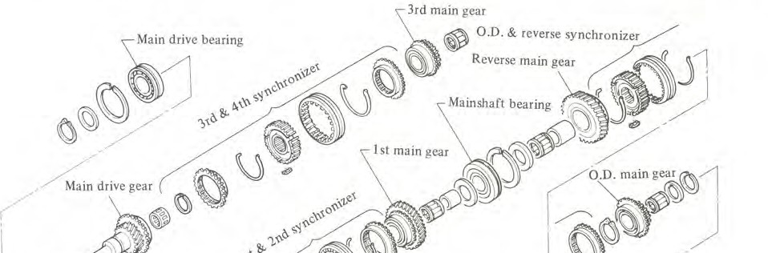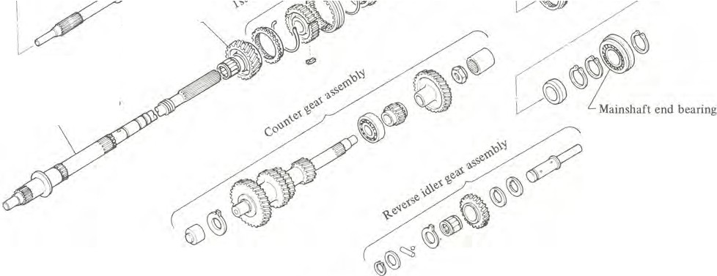
2nd main gear
Mainshaft
0
SMT166

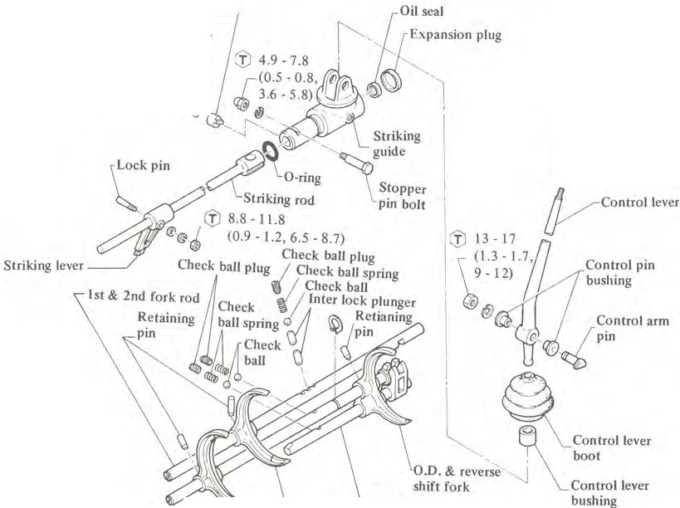
Return spring plunger---� Return spring
J,
Return spring plug �
(J) 4.9 -9.8 (0.5, 1.0, 3.6 • 7.2)1.

�Control lever
U
knob

(I) :

N·m (kg-m, ft-lb)
- O.D. & reverse fork rod
Ist & 2nd shift fork
3rd & 4th shift fork
\ 3rd & 4th fork rod SMT167

DISASSEMBLY
TRANSMISSION CASE DISASSEMBLY
I. Prior to disassembling transmis-sion, thoroughly wipe off dirt and grease front it.
- Drain oil thoroughly.
- Remove dust cover from trans-mission case.
Remove release bearing and with-
drawal lever.
- Remove nut and stopper pin bolt from rear end of rear extension.

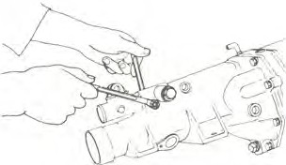

- Remove return spring plug, return spring, and plunger from rear exten-sion.

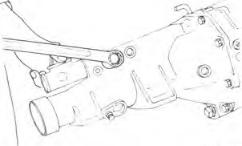

- Remove reverse lamp, neutral, Top and O.D. gear switches (if so equipped).
- Remove speedometer pinion as-sembly.
TM783 TM784

- Remove reverse check sleeves as-sembly.
- Remove front cover. Detach O· ring and front cover adjusting shim.
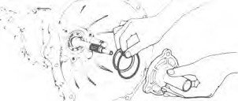

TM786

- Remove main drive bearing snap ring with snap ring pliers.
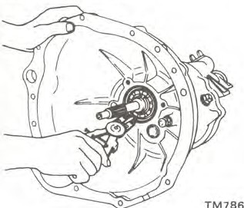

- Remove rear extension secur-ing bolts and turn striking rod clock-wise.
Drive out rear extension backward
using a standard puller.
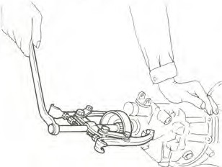
STM170

- Separate transmission case from adapter plate by evenly tapping around it with a soft hammer.

CAUTION:
Do not pry transmission case or rear extension from adapter plate with screwdriver.

)
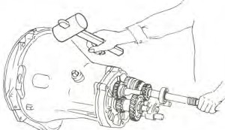
SMT171

- Set up Adapter Setting Plate KV32100300 on adapter plate.
Place the above assembly in a vise.
KV32100300
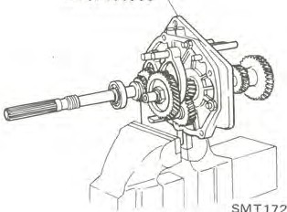

- Detach counter gear thrust washer.

DISASSEMBLY OF GEAR ASSEMBLY
Shift forks and fork rods
I. Drive out retaining pins from each fork rod with Fork Rod Pin Punch ST23540000.

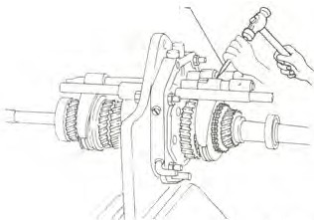
ST23540000
3MT173

- Remove three (3) check ball plugs.

=r==:t; I � t--=
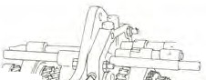
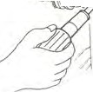
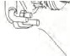
I -

///
\

SMT174

- Drive out fork rods from adapter plate by lightly tapping on the front end.
Detach shift forks.
Note:
  - Be careful not to lose three (3) check balls and two (2) interlock plungers.
  - Each gear and shaft can be de-tached from adapter plate without removing each fork rod.
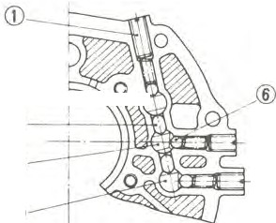

®---+ :::,._��
@
©
@
l Check ball plug
- Fork rod (1st & 2nd)
- Interlock plunger
- Fork rod (3rd & 4th)
- Fork rod (O.D. & Reverse)
- Check ball
TM793

Gear assembly
Note: It is necessary to measure end play, before disassembling main-shaft and after reassembling main-shaft. Refer to Inspection for Gears and Shafts.
I. Remove snap ring of mainshaft end bearing. Draw out bearing using Bearing Puller KV32!01330. Remove

other snap ring of mainshaft end bear-ing.
_/d

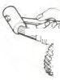
� �:',..i.\f°l-" -
-
'7'
If

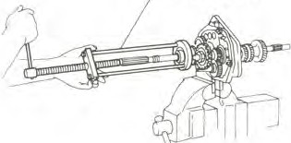
KV32101330
'11
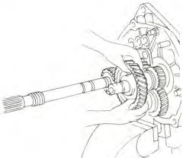
I'
-
),-�
. ,. ,

¾
- '
( ' j \
I �;::_ _?:·
-...J ·1

SMT176

(S) Thrust washer.

SMT179
SMT185

- Remove snap ring and spacer from reverse idler shaft.

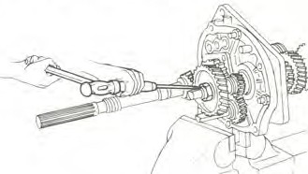
  - With Ist and reverse gears doubly engaged, release staking on counter gear nut then loosen it.
- Remove four (4) bearing retainer
attaching screws with an impact driver and remove bearing retainer.

r-�
11/o''

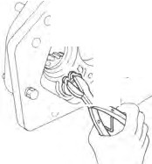
.'
�
�
'1
�
I

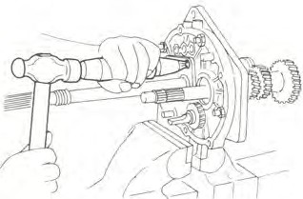
SMT177

  - Remove following parts from mainshaft and counter shaft in rear ex-tension side:
(l) Counter gear nut.
- Mainshaft holder snap ring, C-ring holder, C-ring and thrust washer.

SMT183
- Remove snap ring from main-shaft rear bearing using snap ring pliers.

- T:i.p reverse idler shaft.
SMT180

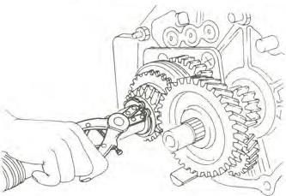
SMT178

- Remove O.D. main gear with needle bearing and O.D. counter gear at the same time.
- Remove baulk ring, coupling sleeve, O.D. and reverse synchronizer hub snap ring, O.D. and reverse syn-chronizer hub, and reverse main gear together with needle bearing and bushing, and reverse counter gear simultaneously.

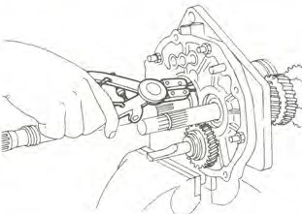
SMT184

- Drive out mainshaft gear as-sembly together with counter gear assembly by lightly tapping the rear end with a soft hammer while holding the front of mainshaft gear assembly and counter gear assembly by hand.
Remove counter gear, main drive gear and mainshaft assembly in that order.

CAUTION:
Be careful not to drop gears.

SMT181
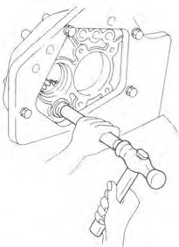
- Draw out retaining pin from reverse idler shaft with Fork Rod Pin Punch ST23540000 and remove idler shaft.
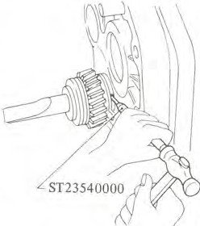 SMT182
I0. Remove thrust washers, spacer and reverse idler gear with needle bear-ing.

3 Spread spring | 13 | I st & 2nd synchronizer hub | 23 | 0.D.gear
4 3rd & 4rh synchronizer hub | 14 | Ist gear | 24 | Needle bearing
5 Shifting insert | 15 | I st gear bushing | 25 | Tluust washer
6 Coupling sleeve | 16 | Thrust washer | 26 | C-ring
7 3rd gear | 17 | Mainshaft bearing | 27 | C-ring holder
8 3rd gear bearing | 18 | Snap ring | 28 | Mainshaft holder snap ring
9 Mainshaft | 19 | Reverse gear bushing | 29 | Mainshaft end bearing snap ring
10 Steel ball | 20 | Reverse gear | 30 | Mainshaft end bearing | SMT186

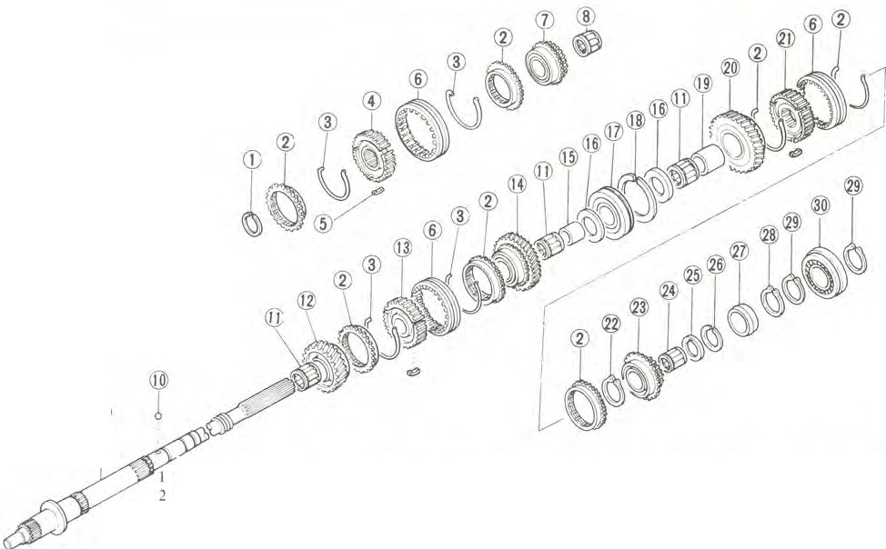
Disassemble mainshaft gear assem-bly as follows:
Mainshaft
®
Snap ring Baulk ring
II Needle bearing
12 2nd gear
21 O.D. & reverse synchronizer hub
22 Snap ring
I. Remove snap ring from mainshaft front end.
Remove 3rd & 4th synchronizer assembly, baulk rings, 3rd gear and mainshaft needle bearing toward front side.

CAUTION:
When pressing out bearing, hold main shaft by hand so as not to drop it.

Main drive gear
I. Remove snap ring and spacer with snap ring pliers.
- Press out main drive bearing with Bearing Puller ST22730000 and a suitable press.

CAUTION:
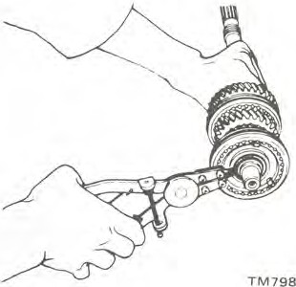
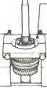
When pressing out bearing, hold gear by hand so as not to drop it.

ST30031000

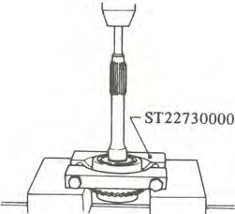
TM693

2. Press out mainshaft bearing using Bearing Puller ST30031000.
- Remove thrust washer and Ist gear together with needle bearing and bushing, baulk rings, coupling sleeve, Ist and 2nd synchronizer hub and 2nd gear with needle bearing.

TM695

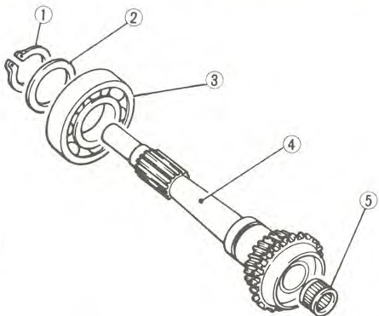
I Snap ring
- Spacer
- Main drive bearing
- Maindrivegear
- Pilot bearing
- Remove lock pin nut and lock pir from striking lever. Remove striking lever.

Counter gear

Syncronizer
TM696
- Remove oil seal with dust cover from rear end of rear extension, and remove striking rod and striking guide.

Press out countershaft rear bearing using Bearing Puller ST3003l 000.

CAUTION:
When pressing out bearing, hold shaft by hand so as not to drop it.
J"

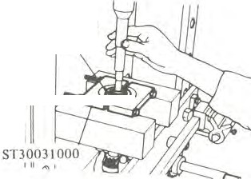
111
Countershaft

be�aring�
I. Remove spread spring (D and take out shming insert®.
- Separate coupling sleeve @ from
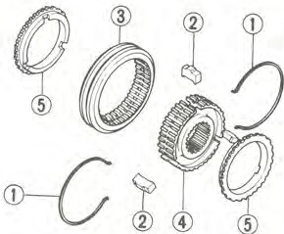
synchro hub©.
Note: Do not remove rear extension bushing from rear extension.

INSPECTION
Wash all parts in a suitable cleaning solvent and check for wear, damage or other faulty conditions.

CAUTION:
- Be careful not to damage any parts with scraper.
- Do not clean, wash or soak oil seals in solvent.

REAR EXTENSION DISASSEMBLY
k

/Lock pin

"'

TMJ51
Spread spring
- Shifting insert
- Coupling sleeve
- Synchro hub
- Baulk ring
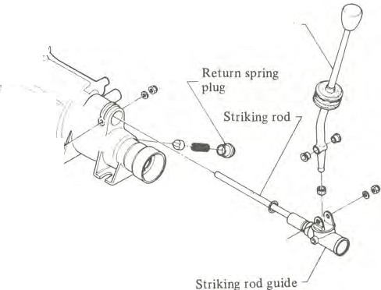
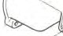
SMT187
Striking lever
Control lever
,
;�
"'
') r-
,<
,iil'�
I
&!.

� Stopper pin boll
Control lever piny·

SMT188
TRANSMISSION CASE AND REAR EXTENSION
- Check for cracks which might cause oil leak or other faulty condi-tions.
- Check mating surface of case to
engine or adapter plate for small nicks, projection or sealant.
Remove all nicks, projection or sealant with a fine stone.
- If rear extension bushing is worn or cracked, replace it as an assembly of bushing and rear extension.
BEARINGS
I. Thoroughly clean bearing and dry with compressed air.

CAUTION:
Do not allow the bearings to spin. Because it will damage the race and balls. Turn them slowly by hand.

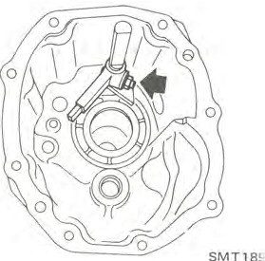

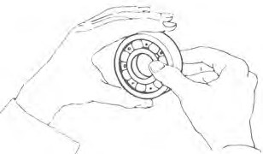

TM372

1 When race and ball surfaces are worn or rough. or when balls are out-of-round or rough. replace bearing.
- Replace needle bear:11g if worn or damaged.

GEARS AND SHAFTS
- Check all gears for excessive wear. chips or cracks: replace as required.
  - Check shaft for bending, crack, wear. or worn spline: if necessary, replace.
- It is necessary to measure end play, before disassembling mainshaft and after reassembling mainshaft. Measure end play to insure that it is within specified limit. If end play is not within specified limit. disassemble and check parts for condition. Replace any part whjch is worn or damaged.

Standard end play: 1st main gear
0.15 • 0.25 mm
(0.0059 • 0.0098 in)
2nd main gear
0.30 • 0.40 mm
(0.0118 • 0.0157 in)
3rd main gear
0.15 • 0.35 mm
(0.0059 • 0.0138 in)
O.D. (5th) main gear
0.30 - 0.40 mm
(0.0118 • 0.0157 in)
Reverse main gear
0.30 - 0.55 mm
(0.0118 • 0.0217 in)
Counter gear
0.10 • 0.20 mm
(0.0039 - 0.0079 in)
Reverse idler gear 0-0.20 mm
(0 • 0.0079 in)

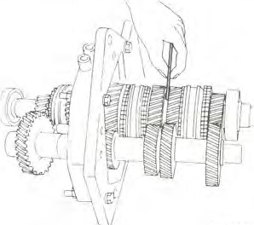
SMT190

- Check for stripped or damaged speedometer pinion gear. If necessary. replace.

BAULK RING
- Replace any baulk ring which is deformed or cracked.
., Position baulk ring in place on gear cone. and measure the baulk ring-to-gear clearance with baulk ring pushed toward gear.
If the clearance is smaller than the specified value. replace baulk ring.
Standard baulk ring-to-cone clearance:
1.10 • 1.40 mm
(0.0433 - 0.0551 in)

If it is less than 0.5 mm {0.020 in), a worn baulk ring may be the cause and a new ring should be fitted.
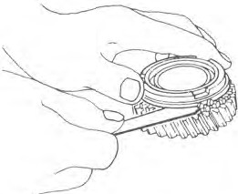
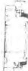
TM806

SHIFTING INSERT
Replace, if worn excessively, worn unevenly, deformed, or damaged.

OIL SEAL
  - Discard O-ring or oil seal which is once removed. Replace oil seal if sealing lip is deformed or cracked. Also discard oil seal if spring is out of position.
1 Check the oil seal lip contacting with shaft; if necessary replace oil seal and shaft as a set.
REAR ENGINE MOUNTING INSULATOR
Replace rear engine mounting insu-lator. if weakened, deteriorated, or cracked.
ASSEMBLY
To assemble, reverse the order of disassembly. Observe the following in-st ructions.

FRONT COVER ASSEMBLY
I. Make sure that seal mating sur-face is clean.
Using a press and Oil Seal Drift ST23800000. drive new seal into place on front cover.
Note: When pressing oil seal into place, apply coat of gear oil to surface adjoining oil seal.
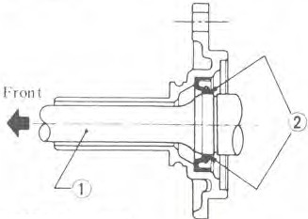
  - Lubricate seal lip and main drive shaft with gear oil when installing front cover.

I Main Jrivc gear
- G�Jr oil TM098A

TRANSMISSION CASE ASSEMBLY
- Press countershaft needle bearing into transmission case from outside.
Note:
  - Needle bearing should not be re-used after removal.
  - When installing needle bearing, be sure to project it 2 mm (0.08 in) from transmission case front sur-face.
  - Make sure that needle bearing turns smoothly.
  - After installing needle bearing,
apply multi-purpose grease to the bearing surface.

Front

2 mm(0.08 in)

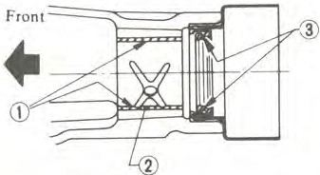
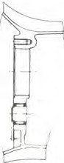
Gear oil
�
TM707 2 Bushing
- Grease TM099A
Mainshaft
I. Assemble 2nd gear needle bear-ing, 2nd gear, baulk ring, Ist & 2nd speed synchronizer assembly, Ist gear baulk ring, I st gear bushing, needle bearing, lst gear. and thrust washer on mainshaft.
'.L Press mainshaft bearing onto mainshaft using Mainshaft Bearing Drift ST22350000.

Countershaft Needle Bearing
- [nstall withdrawal lever ball pin on case and tighten screw.
(fJ: Ball pin
20 - 29 N-m
(2.0 · 3.0 kg-m,
14 • 22 ft-lb)

REAR EX TENSION ASSEMBLY
I . Apply grease to O-ring and plunger grooves in striking rod guide.
Insert striking rod with striking rod guide through rear extension.
  - Install striking lever on front end
of striking rod. Install lock pin and nut, and tighten it.
© : Striking lever lock nut
9 - 12 N•m
(0.9 · 1.2 kg-m,
6.5 - 8.7 ft-lb)
  - When installing expansion plug, apply sealant to it.
  - Make sure that seal mating sur-face is clean.
Using a press and Oil Seal Drift ST35300000, drive new seal into place on rear extension.
Note: When pressing oil seal into place, apply coat of gear oil to surface adjoining oil seal.
  - Coat oil seal lip and bushing with gear oil for initial lubrication. Pack cavity between seal lips with recom-mended multi-purpose grease when in-stalling.

ASSEMBLY OF GEAR ASSEMBLY
Clean all parts in solvent and dry wirh compressed air.

Synchronizers
I. Place synchro hub into coupling sleeve.
- Fit shifting inserts in three grooves in synchronizer hub.
- Install spread spring to inserts so
that insert is securely attached to inner side of coupling sleeve.
Install the other spread spring on the opposite side of synchro hub.
Note:
  - Be careful not to hook front and rear ends of the spread spring to the same insert.
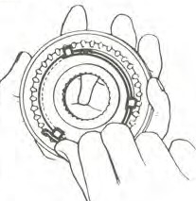
  - Be sure that hub and sleeve oper-ates smoothly and correctly by hand.

TM077

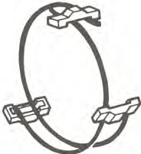
TM131A

ST22350000

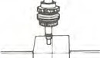
TM711

  - Position 3rd gear needle bearing, 3rd gear, baulk ring, and 3rd & 4th synchronizer assembly on the front side of rnainshaft.
  - Fit a new suitable snap ring in place so that there exists a minimum clearance between end face of hub and ring.
Note: Make sure snap ring fits in groove.
Available snap rings

No. | Thickness mm (in)
 | I.SS - 1.60
 | (0.0610 - 0.0630)
2 | 1.60. 1.65  (0.0630 - 0.0650)
3 | 1.65 • 1.70  (0.0650 - 0.0669)
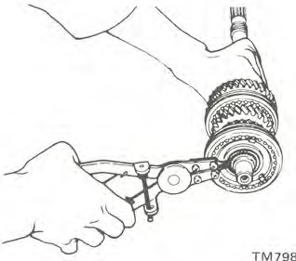

Main drive gear
    - Press m:iin drive gea1· bearing unto shart of main drive gear using Trans-mission Orift ST23800000.
Make sure that snap ring groove on shaft clears bearing.

- �n 21!lonon11

TM714

      - Place main drive bearing spacer on main drive bearing and secure main drive beuring with a new thicker snap ring that will eliminate end play.
Note: Make sure snap ring fits in groove.
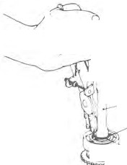
r

w
� '1)1
-CD
Counter gear
I. Install .i counter gear thrust washer and counter ge:ir into transmis-sion .:ase, und select counter gear thrust washer of proper thickness using straight edge.
Select washer from those shown in the following table so that en<l play of counrer gear is specified value.
Standard end play:
0.10 - 0.20 mm
(0.0039 - 0.0079 in)
-i Insert new retaining pin to re-verse idler shaft.
Assembly to adapter plate
I . Install reverse idler shart by tapping with drift.
      - Install thrust washer, reverse idler gear. steel ball and two thrust washers.
      - Position thrust washer and fit a new snap ring in place so that reverse idler gear end play is within specified limit.
Reverse idler gear end play: 0 - 0.20 mm (0 - 0.0079 in)
Nu. | Thickness 111111 (in)
 | 2.'.:!0-2.25
 | (0.0866 - 0.0886)
2 | 2.25 - .:'.30  (0.0886 · 0.0906)
3 | 2.30 - 2.35  (0.0906 - 0.0925)
4 | 2.35-2.40  (0.0925 - 0.0945)
5 | 2.40 - 2.45  (0.0945 - 0.0965)
6 | 2.45 - 2.50  (0.0965 - 0.0984)
7 | 2.50 - 2.55  (0.0984 - 0.1004)
8 | 2.55 - 2.60  (0.1004 - 0.1024)

Available snap rings

No. | Thickness mm (in)
1. | I.I (0.043)
2. | 1.2 (0.047)
      - Install baulk ring on main drive gear. and combine with mainshaft to complete the mainshaft assembly.
Note: Be sure to install pilot bearing in place when combining with mainshaft.
      - Combine mainshart assembly with counter gear assembly, and place

I Main drive g,'ar
- Snap-ring
- Spacer
- Main drive bearing

Available snap rings
(g)
,· �@
- ©

TM715

Note: Be sure to measure at two or more positions on the end surface of counter gear.
them into adapter plate simulta-
neously.
      - Install counter gear assembly to-gether with mainshaft assembly by applying light blows with a soft-faced hammer. Then pull mainshaft assem-bly into adapter plate using Mninshaft Puller KV3210040l. When installing mainshaft assembly, carefully hold gears by hand.
Make sure that snap ring groove on mainshaft rear bearing clears adapter plate.

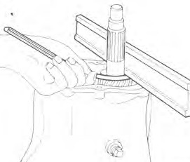
SMT168
No. | Thickness mm (in)
 | 1.34 - l.40
 | (0.0528 - 0.055I)
2 | I .40 - 1.46  (0.055 l - 0.0575)
3 | 1.46 - 1.52  (0.0575 - 0.0598)
4 | J.52-1.58 (0.0598 - 0.0622)
5 | 1.58 - I .64  (0.0622 - 0 0646)
6 | l.64 - 1.70  (0.0646 - 0.0669)
7 | 1.70 - 1.76  (0.0669 - 0.0693)

'l Remove counter gear from the
CAUTION:
- Take care not to drop gears on floor.
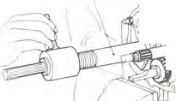
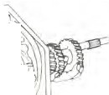
- Take care not to damage bearings.
!J:_
l,
V
/ , .-�'c.>i- I
\ ,,.. .-

KV3210040I

transmission case.

Reverse idler gear
I, Positiun thrust washers, needle bearing. reverse idler gear and thrust washer.

  - •r. I I .J
SMT192

      - Fit snap ring to groove in main-shaft rear bearing with snap ring pliers.
Available snap rings
JS. With 1st and reverse gears doubly engaged, tighten countershaft nut to

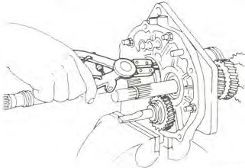
No.

3,
4.
s.
Thickness mm (in)

1.32 (0.0520)
l .38{0.0543)
l .46 (0.0575)
1.54 (0.0606)
1.62 (0.0638)
converted torque "C" using Wrench

SMT258

Note: Make sure snap ring fits in
groove.
      - lnstaJl bearing retainer on adapter plate.
Torque screws and stake each screw at two points with a punch.
©: Mainshaft bearing retainer screw
6.9 - 9.8 N•m
(0.7 • 1.0 kg-m,
    - • 7.2 ft-lb)
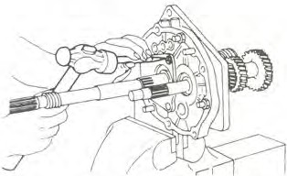
SMT193

Note: Make sure snap ring fits in groove.

J2. Position baulk ring, 0.0. gear needle bearing, 0.0. main gear and steel ball, on end of mainshaft.
- Install O.D. counter gear on end
of countershaft.
- Position C-ring, C-ring holder and thrust washer in place and select thrust washer so that 0.0. gear end play is withfo specified limit.
0.0. (5th) gear end play:
0.30 • 0.40 mm
(0.0118 - 0.0157 in)

Note: Make sure snap ring fits in groove.

Available thrust washers

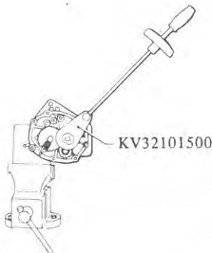
SMT194
KV3210500.

Stake countershaft nut to groove of countershaft with a punch.

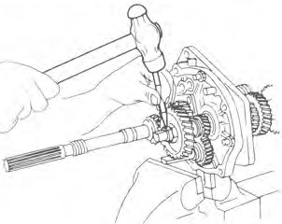
SMT195
No.
Thickness mm (in)
I.
2.
3.
4.
5.
6.
7.87 (0.3098)
7.94 (0.3126)
8.01 (0.3154)
8.08 (0.3181)
8.15 (0.3209)
8.22 (0.3236)

      - Position thrust washer, reverse gear bushing, needle bearing and reverse main gear on end of main-shaft.
      - Install reverse counter gear on end of countershaft.
      - Install O.D. & reverse synchro-nizer assembly and fit a new suitable
snap ring in place so that reverse main gear end play is within specified limit.
Reverse main gear end play:
0.30 - 0.55 mm
(0.0118 - 0.0217 in)

Note: Make sure snap ring fits in
groove.

N·m (ft-lb) (kg·m)
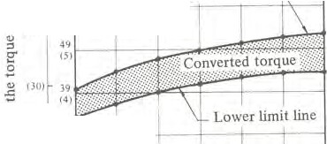
1501 69
111
.c
cCJ;
Upper limit line
1,1------,1---1---
�
MO)
c;
0
24
110) CH

10
Ol
u 001
fl_l
0,2 (),J II4 p.� u.n 111 I) 8 m
Ill

II 01 11 ,1 (l.01 r,s, (ft)
t: Effective length of torque wrench SMT196

Explanation of converted torque
Mainshaft nut should be tightened to 49 to 59 N-m (5 to 6 kg-m, 36 to 43 ft-lb) torque with the aid of Wrench KV32101500. When doing so, the amount of torque to be read on wrench needle should be modified ac-cording to the following formula:

C N•m = 49 x (L + L
0.l ) to
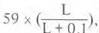

C(kg-m)=Sx(L+�.I )to
18. lnstall mainshaft end bearing using Bearing Drift ST22350000. Fit thick snap ring to the rear side of bearing to eliminate end play.

Available snap rings

No. | Thickness mm (in)
I. | I.IS (0.0453)
2. | l.2 (0.047)

  - Insert Ist & 2nd fork rod into adapter plate and its shift rork.
  - Secure shift forks and fork rods with new retaining pins.
Note:
- Be sure to install interlock plunger when installing any adjacent fork rods to adapter plate.
Properly align the groove in assem-bled fork rod with interlock plung-er.
- Be sure to align 3rd & 4th shift
fork with the groove in their coupling sleeve before installing.
- Also properly align Ist & 2nd and 0.D. & reverse shift forks with their coupling sleeves before install-ing.

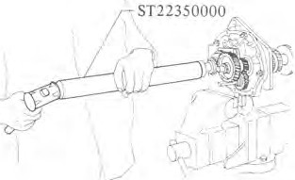
L
6
x( L+O.l)
or
  - Install check balls and check ball springs. Applying locking sealer to check ball plug and install in place.

C (ft-lb)= 36 x (L +�_33
) to
SMT198
Align center notch in each fork rod with check ball.

Where.
+ 0.33
43x ( L L )

Shift forks and fork rods
I. Insert 0.0. & reverse fork rod
Note:
- Check ball plug as Ist & 2nd fork rod is longer than those for 3rd &

C: Value read on the torque wrench
N-111 (kg-m, ft-lb)
L: Effective length of torqtte wrench
m (ft)

, KV32l01500 C

0.1 m
(0.3 fl)
into its shift fork and adapter plate.
- With 0.D. & reverse fork rod set at Neutral, insert interlock plunger into adapter plate.
- Insert 3rd & 4th fork rod into
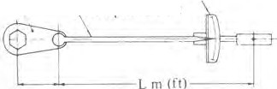
0.D. & reverse fork and fit a new snap ring to 3rd & 4th fork rod.
Torque wrench
- Insert 3rd & 4th fork rod into adapter plate and its shift fork.
- With 3rd & 4th fork rod set at Neutral, insert interlock plunger into adapter plate.
4th fork rod and O.D. & reverse fork rod.
- To insure that interlock plunger is installed properly, slide 1st & 2nd fork rod and operate the other fork rods. Make sure that gears except 1st and 2nd gear do not mesh.
  - Apply gear oil to all sliding sur-faces and check to see that shift rods operate correctly and gears engage smoothly.

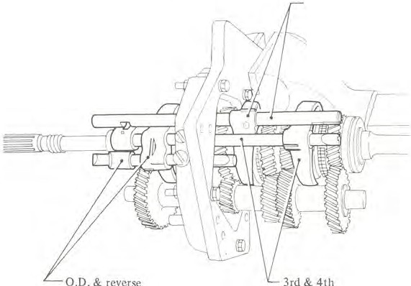
TM587
1st & 2nd

Example,
when a 0.4 m-long torque wrench is used. the "C" in figure will be 39 to 47 N-m (4.0 to 4.8 kg-m, 29 to 35 ft-lb).

- Measure gear end play.
Make sure that they are held within the specified values.
For details, refer to Gears and Shafts for inspection.
- Fit I .15 mm (0.0453 in) thick
snap ring to the front side of main-shafl end bearing.

SMT199

TRANSMISSION ASSEMBLY

Transmission case assembly
- Remove adapter plate with gear assembly from Adapter Setting Plate KV32100300.
- Clean mating surfaces of adapter plate and transmission case.
Apply sealant to mating surfaces or adapter plate and transmission case.
- Install counter gear thrust washer selected previously.
Note:
  - Apply grease to sliding surface of thrust washer.
  - When installing thrust washer, note the front and rear directions.
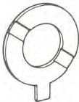
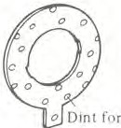
Oil
hont (Oil �move ,idci Rc:tr (Tl1ru,1 side)
TM727

- Place wooden plate of more than 20 mm (0.79 in) thick under transmis-sion case to make it level.
Slide transmission case onto adapter plate by lightly tapping with a soft hammer until case bears against adapter plate, and be sure to line up dowel pin.
Carefully install main drive bearing and counter gear front needle bearing.
Make certain that mainshaft rotates freely.
Note: Make sure snap ring fits in
groove.

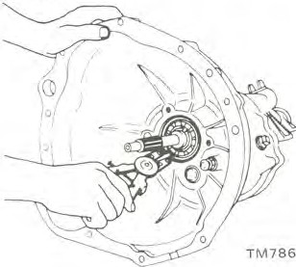

Rear extension assembly
I. Clean mating surfaces of adapter plate and rear extension.
Apply sealant to mating surfaces of adapter plate and rear extension.
- Install rear extension as follows:
(I) Set gears at Neutral.
- Turn striking guide counter-clockwise.
- Set striking guide at Neutral.
- Align end of striking lever with cutout portion of fork rod.
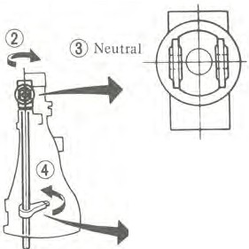
�
© SMT478
Note:
- Use care when installing rear ex-tension assembly. Do not allow sl1ift arm to come out of the strik-ing lever.
- Install shift arm onto 0.D. & re-verse fork rod, and then fit striking lever pin into other fork rods.
- Install through-bolts with wash-ers.
®: Rear extension installation
bolt
16-22N•m
(1.6 · 2.2 kg-m,
12-16ft-lb)

- Apply grease to plunger: install it in rear extension.
- lnstall return spring.
Apply locking sealer to return spring plug and install it in place.
:fJ : Return spring plug
4.9- 9.8 N•m
(0.5 - 1.0 kg-m,
3.6 - 7.2 ft-lb)

Front cover assembly
I. Select front cover adjusting shim as follows:
(I) Using vernier caliper depth gauge measure depth "A" from front end of transmission case to main drive bearing outer race with front cover adjusting shim in place.
(2) Select a shim of thickness ''A"

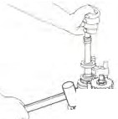
� ,-�-�
y
No. | "A" mm (in) | Adjusting shim  mm (in)
 | 6.05 - 6.09 (0.2382 - 0.2398) | 0.50(0.0197)
1 | 6.10- 6.14 (0.2402- 0.2417) | 0.55 (0.0217)
3 | 6.15- 6.19 (0.2421 -0.2437) | 0.60 (0.0236)
4 | 6.20 - 6.24 (0.2441 - 0.2457) | 0.65 (0.0256)
5 | 6.25 - 6.29 (0.2461 - 0.2476) | 0.70 (0.0276)
6 | 6.30 - 6.34 (0.2480 - 0.2496) | 0.75 (0.0295)
7 | 6.35 - 6.39 (0.2500 - 0.2516) | 0.80 (0.0315)

� I
Wooden \
bJo,k {

SMT200
- Fit main drive bearing snap ring to groove in main drive bearing with snap ring pliers.
MT-14

Tn,nsmission c:asc
- M�in drive gear
- Adjusting shim
- B�aring

TM817

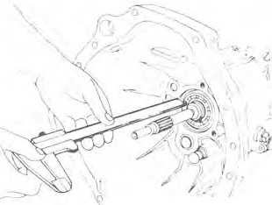
_., TM816
I

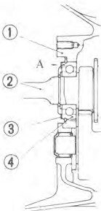

- Install front cover to transmission case with the adjusting shim and 0-ring in place.
(il : Front cover installation bolt 10-16 N•m
(1.0 -1.6 kg-m,
7 -12 ft-lb)

Outer parts assembly
I. Install speedometer pinion assem-bly and install securing bolt and tighten.

'f1 : Speedometer sleeve locking
plate bolt
2.9 • 4.9 N•m
(0.3 • 0.5 kg-m,
2.2 • 3.6 ft-lb)
- Fit a new 0-ring to groove in reverse check sleeve, install it in place and tighten reverse check sleeve bolts.
- Install reverse lamp switch and tighten. At the same time, install neutral, top and 0.D. gear switches if so equipped.
Be sure to apply locking sealer before installation.
..J) : Reverse lamp, neutral, top and O.D. gear switches
20 • 34 N-m
(2.0 · 3.5 kg-m,
14 · 25 ft-lb)
- Apply a light coat of multi-purpose grease to withdrawal lever, release bearing and bearing sleeve; in-stall them on transmission case.
After coru1ecting them with holder spring. install dust cover Io transmis-sion case.
- Install control lever temporarily, and move shift control lever through all gears to make sure that gears operate smoothly.
- Install drain plug coated with sealant in place.

'.T) : Drain plug
25 • 39 N·m
(2.5 • 4.0 kg-m,
18 • 29 ft-lb)
- Make sure that main drive shaft rotates smoothly in Neutral.
Main drive gear rotating torque:

2. Clean mating surfaces of front
cover and transmission case.
Less than 0.18 N-m
(1.8 kg-cm, 1.6 in-lb)

SERVICE DATA AND SPECIFICATIONS (S. D.S.)

GENERAL SPECIFICATIONS

Engine model |  |  |  | A15 | A14 | A15 | A12A
Transmission model |  |  |  | FS5W60A |  | F4W60L | F4W56A
No. of speeds |  |  |  | 5 |  | 4 | 4
Synchromesh type |  |  |  | Warner
Shift pattern |  |  |  | 1 3 5  I_J  J--1-7  2 4 R |  | 1 3  J---;7  2 4 R
Gear ratio |  | 1St |  | 3.513 | 3.513 | 3.513 | 3.757
 |  | 2nd |  | 2.170 | 2.170 | 2.170 | 2.169
 |  | 3rd |  | 1.378 | 1.320 | 1.378 | 1.404
 |  | 4th |  | 1.000 | 1.000 | 1,000 | 1.000
 |  | 0.0. (5th) |  | 0.821 | 0.821 | - | -
 |  | Rev. |  | 3.764 | 3.764 | 3.764 | 3.640
Final gear ratio |  |  |  | 3.700 | 3.545 | 3.700 | 3.889
Number of teeth |  | Mainshaft | Drive | 20 | 20 | 20 | 19
 |  | Mainshaft | 1St | 34 | 34 | 34 | 32
 |  | Mainshaft | 2nd | 28 | 28 | 28 | 27
 |  | Mainshaft | 3rd | 24 | 23 | 24 | 23
 |  | Mainshaft | 5th | 18 | 18 | - | -
 |  | Mainshaft | Rev. | 34 | 34 | 34 | 31
 |  | Counter-shaft | Drive | 31 | 31 | 31 | 29
 |  | Counter-shaft | 1St | 15 | 15 | 15 | 13
 |  | Counter-shaft | 2nd | 20 | 20 | 20 | 19
 |  | Counter-shaft | 3rd | 27 | 27 | 27 | 25
 |  | Counter-shaft | 5th | 33 | 33 | - | -
 |  | Counter-shaft | Rev. | 14 | 14 | 14 | 13
 |  | Rev. idler shaft |  | 22 |  | 22 | 17
Speed· ometer gear ratio | Tire | 6.00-12-4PR |  | - |  | - | 17/5
Speed· ometer gear ratio | Tire | 155-13/6.15-13-4PR |  | 16/5
Speed· ometer gear ratio | Tire | 155SR13 |  | 16/5
Speed· ometer gear ratio | Tire | 175/70SR13 |  | 16/5
Oil capacity liter (US pt, Imp pt) |  |  |  | 1.2 (2-1/2, 2-1/8) |  | 1.3 (2-3/4, 2-1/41 | 1.2 (2-1/2, 2-1/8)

MT-41

INSPECTION AND ADJUSTMENT

el  m  � |  | FS5W60A | F4W60L | F4W56A
 | 1st main gear | 0.15 - 0.25  (0.0059 - 0.0098) | 0.15-0.25  (0.0059 - 0.0098) | 0.15 - 0.25  (0.0059 - 0.0098)
 | 2nd main gear | 0.30 - 0.40  (0.0118 - 0.0157) | 0.30 • 0.40  (0.0118 - 0.0157) | 0.15 - 0.25  (0.0059 - 0.0098)
 | 3rd main ge.ir | 0.15 - 0.35  (0.0059 - 0,0138) | 0.15-0.35  (0.0059 • 0.0138) | 0.10-0.30  (0.0039 - 0.0118)
Gear end play  mm (in) | 0.0. (5th) main gear | 0.30 • 0.40  (0.0118 - 0.0157) | - | -
 | Reverse main gear | 0.30 • 0.55  (0.0118 - 0.0217) | - | -
 | Counter gear | 0.10-0.20  (0.0039 -0.0079) | 0.10 - 0.20  (0.0039 • 0.0079) | 0 • 0.20  (0 • 0.0079)
 | Reverse idler gear | 0 • 0.20  (0 • 0.0079) | 0.10 • 0.27  (0.0038 • 0.0106) | -
Clearance between baulk ring and gear  mm (in) |  | 1.10 -1.40  (0.0433 • 0.0551) | 1.10 - 1.40  (0.0433 - 0.0551) | 1.05 • 1.40  (0.0413 • 0.0551)
Main drive gear rotating torque  N·m (kg-cm, in-lb) |  | Less than 0.18 (1.8, 1.6) | Less than 0.18 (1.8, 1.6) | Less than 0.18 (1.8, 1,6)

TIGHTENING TORQUE
Unit | N·m | kg-m | ft-lb
Transmission installation
Transmission to engine installation bolt | 16 • 22 | 1.6 - 2.2 | 12 - 16
Transmission to engine rear plate installation bolt | 16 • 22 | 1.6 - 2.2 | 12 - 16
Transmission to gusset installation bolt | 45 - 60 | 4.6 - 6.1 | 33 -44
Starter motor to trans-mission installation bolt | 29 • 39 | 3.0 -4.0 | 22• 29
Rear mounting insulator to transmission installa-tion bolt | 8.8 - 11.8 | 0.9 -1.2 | 6.5-8.7
Crossmember mounting bolt | 31 -42 | 3.2 - 4.3 | 23 • 31
Rear engine mount in-stallation bolt | 8.8 - 11.8 | 0.9 - 1.2 | 6.5 • 8.7
Clutch operating cylin-der installation bolt | 30 • 40 | 3.1 • 4.1 | 22 • 30
Propeller shaft to dif-ferential carrier | 24- 32 | 2.4• 3.3 | 17 • 24
Control lever pin instal-lation nut (FS5W60A, F4W60L) | 13 • 17 | 1.3 - 1.7 | 9 -12
Exhaust mounting brack-et to exhaust front tube | 31 • 42 | 3.2 -4.3 | 23 -31
Gear assembly
Ball pin | 20 • 29 | 2.0-3.0 | 14 • 22
Striking lever lock nut (FS5W60A, F4W60L) | 8.8 • 11.8 | 0.9 • 1.2 | 6.5 -8.7
Striking lever set screw (F4W56A) | 5.9 -9.8 | 0.6 -1.0 | 4.3-7.2
Mainshaft bearing retainer screw (FS5W60A, F4W60U | 6.9 -9.8 | 0.7 • 1.0 | 5.1 • 7.2
Counter shaft lock nut (FS5W60A) | 49 • 5.9 | 5.0 -6.0 | 36 -43
Rear extension installa-tion bolt | 16- 22 | 1.6 • 2.2 | 12 - 16
Stopper pin bolt (FS5W60A, F4W60U | 4.9 • 7.8 | 0.5 -0.8 | 3.6 • 5.8
Front cover installation bolt | 10 -16 | 1.0 - 1.6 | 7 • 12
Speedometer sleeve lock-ing plate bolt | 2.9 • 4.9 | 0.3 -0.5 | 2.2 - 3.6
Topgear switch | 20. 34 | 2.0 -3.5 | 14 • 25

Unit | N·m | kg-m | ft-lb
0.0. gear switch (FS5W60A) | 24 • 34 | 2.0 -3.5 | 14 • 25
Neutral switch (FS5W60A) | 20 - 34 | 2.0 • 3.5 | 14 • 25
Reverse lamp switch | 20 - 34 | 2.0 • 3.5 | 14 • 25
Return spring plug | 4.9 -98. | 0.5• 1.0 | 3.6• 7.2
Gear oil filler plug | 25 • 39 | 2.5 - 4.0 | 18 • 29
Gear oil drain plug | 25 -39 | 2.5 • 4.0 | 18 • 29

MT-43

TROUBLE DIAGNOSES AND CORRECTIONS

Noise

+
Check level and color of oil.
Lcvc!lcol\lr no1 0.K. Level and color O.K.

Add/replace llil. (1r nil leaks repair cause.)
+

Check noise.

Noise docs nol stop.

locate which kes noise.
.. Shifl gears and
gear position ma

i
Noise slup,.
•
0.K.
Noise in Neul ral
•

Disengage clutch tu
sec if noise slnps.

Noise in posilion other tl1J11 Neutral

Noise dues no1 stop.
+

Noise outside transmission. Check engine and clutch. etc.
Noise stops.
t
Noise in transmission. Noise may
be caused by variations in engine torque.
Adjust engine idle speed.

Noise occurs in a specific gear position, and peaks at specific engine rpm, and stops with gears in TOP position.

Noise appears to occur in transmission. Disassemble and check gear in which noise occurs for meshing surface and bearings.
!
Replace gear and/or bearing.
Noise occurs in all positions except Neutral and peaks at a specific car speed.

Noise source appears to be located in differential carrier. Check differential carrier and eliminate cause of noise.
t
High roaring noise occurs in all positions and peaks at specific engine rpm.

i
Noise occurs while shifting
gears.

j
Refer to the section "Faulty Synchromesh Mechanism,•.
Gears grate while synchro-nizing.

Noise occurs when stroking further after shift�g gears.
l

Moving parts (couplings, gears, etc.) of transmission interfering with other parts.

Gear jumping out of mesh

N.G.
i
Locate pusiuon where gears jump out of mesh.

l
- Check for free play in c.:on trol lever.
- Shifting is accomplished without problems. (Check interference of control lever with console. and check rubber boot of control lever for fatigue.)

0.K.
l
+

Replace.

N.G.
i
Adjust or replace.
Check for fatigue, play. etc. on front and rear engine mounts.

Problem may be inside transmission. Disassemble and check transmission.
Check end play o*f "jump-out" gear.

i

End play,...e_x_c_e_ss iv_e J. E_n_d-,:lay O.K.

i
Replace. Check for engaging, damage or wear on
coupling sleeve. synchronizer hub, and clutch gear of main gear.

Damage or wear O.K.

Replace.

Damage or wear
i
Replace.

Wear or deformation

Replace.

Wear or play
i
Replace.
Check for wear or damage on check ball and
faUg,e oc bceaks o:rck spUog.

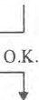
Check for wear nr deformation of fork rod ball groove.

Check for wear or play of "jump-out" synchro-nizer and mainshaft splines.

No w,u{, play

Check for wear or damage on bearings of main• shaft and countershaft. Replace if worn.

Difficult gear meshing/shifting

N.G.
!
Shift gears up and down while operating car to sec if gears shift smoothly.

Shift gears while engine is OFF.
+
I

0.K.

l

Check for proper installa-tion or control lever.
N.G. 0.K.

N,G.

i
Chee!- engine idle speed,
I

O.K.
,I,

Repair or replace.
AJjust.
  - Check for improper dis-engaging of clutch.
  - Check for improper oper-ation of clutch operating cylinder/master cylinder.

Oper;1tiun
N.G.

O.K.

Operation
,,

Repair clutch.
Check lubrication oil level
:ind color.

N.G. 0.K.

Add/replace oil.

,,
Check for smooth shifling while t:ar is operating.
N.G. O.K.
..,
Instructs customers in correct

Problem may be inside transmission. Remove trans-mission from car, disassemble it and check it for source of difficult meshing/shifting of gears.

t
Check operation of striking rod.
shifting method.

N.G.
!
Repair or replace.
I 0.K.
�
Check operation of fork rod.

fork rod or scratched case.

N.G.
O.K.
Check for possible bent
Seratched/bent
,�,
Replace.
L
,
'
Replace.
Check gear end faces and gear bores for any sign of sticking/jamming.
If detected,. replace faulty parts.
Check engaging of hub, cou-pling sleeve, clutch gear, etc.

t
Faulty synchrnrnesh mechanism
( Noise th;curs while shifting gears)
Locale pusil1u11 where improper syncliru-rni.:-�liing occurs.

Cherk <lise11gag111g of clutch. (Refer 10 C'lu1ch Drags (Section CL) fur trouble diagnoses and uirrcctions.
+
N.G. 0.K.

l
Rcpai, "' rcplarc. Problem may be inside 1ransmision.
Disassemble and check transmission.
l

Measure baulk ring-to-gear clearance. Refer to Baulk Ring for inspection.

(')earanee
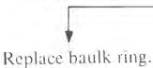
N.G.

Clearnnc� O.K

Check for wear on chamfered area or baulk ring.

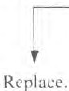
Chamfered area worn Chamfered area not worn
Check contact pattern of baulk ring and tapered cone of clutch gear.

Improper conlart Proper contact

i
Replace baulk ring.
Check spread+spring for any break or bending.

Spread spring
broken/hen t Spread spring not broken/bent

Replace. Check for wear/defonnation
of insert.
Refer to Shirting Insert for inspection.

SPECIAL SERVICE TOOLS

Tool number (Kent-Moore No.) | Tool name |  | Unit application
Tool number (Kent-Moore No.) |  |  | FS5W60A | F4W60L | F4W56A
KV32100300 (]25693) | Adapter setting plate w |  | X | X | X
ST23540000 (125689) | Fork rod pin punch |  | X | X | X
ST22730000 (125681) | Bearing puller | � | X | X | X
ST30031000 (125733-1) | Bearing puller | � | X | X | -
ST33061000 (J25797-2) | Oil seal drift | � | - | - | X
ST35300000 ( - ) | Oil seal drift | � | X | X | X
ST23800000 (125691) | Transmission drift | / | X | X | -
ST22350000 (125678) | Mainshaft bearing drift | / | X | X | X
KV32100200 ( - ) | Countershaft bearing press stand | @ | - | X | X
ST23050000 (]25684) | Counter gear height gauge |  | - | - | X

Unit application
FSSW60A
F4W60L
KV32100100 (126070)
Counter gear height gauge
0
{1/
F4W56A
-
X
-
ST23620000 (J25690-0I)
Interlock ball guide
-
-
X
KV32100400 (126071)
Mainshaft puller
�(S)
-
X
-
KV32100401 (J26071-8)
Mainshaft puller
��
X
X
-
Tool number (Kent-Moore No.)
Tool name
X
-
-
�
KV32101330
(See J26349)
Bearing puller
rti?
X
-
-
KV32101500 (J28804)
Wrench

